

|  |  |  |
| --- | --- | --- |
|  | **Frank Fowler Dow School No. 52**  100 Farmington Road,  Rochester, New York 14609  Phone (585) 482-9614 Fax (585) 654-1079  www.rcsdk12.org/52 | Dr. Mary Ferguson  Principal  Mary.Ferguson@rcsdk12.org |

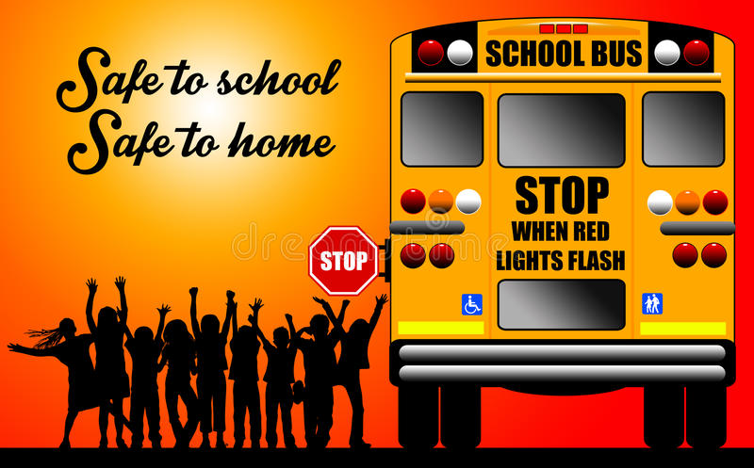

Parking is frequently a concern at School #52. We ask that you take care not to park block driveways during arrival and dismissal times. When you come to the school for any reason, please be extra careful to not block driveways and school crosswalks either parking or standing. Even if you are remaining in your car while you wait for your child, it is not acceptable to block a driveway or the school crosswalks. City residents have the right to call the RPD to have parking violators ticketed or towed. Please avoid such costly and unpleasant occurrences by parking according to the City of Rochester parking regulations at all times. This also includes parking on the LEGAL side of the street.

Also do not ask your child to cross the street **between** busses. This is not acceptable nor is it safe.

Another problem area has been the intersection of Farmington and Presque Streets. Pedestrian visibility can be limited by parked vehicles, or school busses waiting to pull into the bus lane. Please travel slowly through that intersection, keeping an eye open for the small walkers in that area. Remember: safety first, last and always!

Thank you for your cooperation.

Sincerely,

Dr. Mary Ferguson

Principal